Tasks
OBJECTIVE QUESTIONS

Q1) What is the total no. of attributes present in the data?
Ans->
10 attributes (columns) in the Tickets sheet.
06 attributes (columns) in the IT Agents sheet.

-----------------------------------------------------------------------------------------------------------------------------------------------------

Q2) Which columns have inconsistent or missing values, and what is the count of such values?
Ans->
There is no missing values as such— all 97,498 rows are fully filled
However, Following Changes have been made due to inconsistency in Data with the help of Search and Replace
- ‘Mayor’ spelling changed to “Major” 4,836 rows replaced
- ‘Unassiged’ spelling changed to “Unassigned” 29,410 rows replaced
- ‘Mid’ spelling changed to “Medium” 15,845 rows replaced
- ‘Unclasified’ spelling changed to “Unclassified” 356 rows replaced

-----------------------------------------------------------------------------------------------------------------------------------------------------

Q3) What is the average daily ticket volume over time?
Ans->
I have made a Pivot Table, to calculate total numbers of ticket handled each day.
Through which I calculated average daily ticket volume over time
On an Average, around 53.37 tickets are raised per day.
Syntax to find the Average of Daily Ticket Volume is mentioned below:-
=AVERAGE(B7:B1833)
Ticket Volume Over Time->
Average of (B7:B1833) | 53.37

-----------------------------------------------------------------------------------------------------------------------------------------------------

Q4) What is the distribution of ticket categories (e.g., Login Access, System, Software)?
Ans->
I have made a Pivot Table, to find total distribution of ticket across different categories.
Hardware has 9,733 Tickets.
Login Access has 29,193 Tickets.
Software has 19,570 Tickets.
System has 39,002 Tickets.
Category | Sum of Total Ticket
Hardware | 9733
Login Access | 29193
Software | 19570
System | 39002
Grand Total | 97498

-----------------------------------------------------------------------------------------------------------------------------------------------------

Q5) How many tickets has each agent handled?
Ans->
I have made a Pivot Table, to calculate total numbers of ticket each Agent handled.
On an Average, each Agent Handled 1950 Tickets
Syntax to find the Average of Ticket each Agent handled is mentioned below:-
=AVERAGE(M7:M56)
Ticket each Agent Handled
AVERAGE of (M7:M56) | 1950

-----------------------------------------------------------------------------------------------------------------------------------------------------

Q6) How can you extract the domain from the email addresses in the IT Agents sheet?
Ans->
We can Extract the domain with the help of ‘RIGHT’ and ‘FIND’ function
Syntax to find the Domain is mentioned below:-
=LEFT(RIGHT(O7,LEN(O7)-FIND("@",O7)),FIND(".",RIGHT(O7,LEN(O7)-FIND("@",O7)))-1)
- FIND("@",O7) => finds where the @ is.
- LEN(O7)-FIND("@",O7) => calculates how many characters are after @.
- RIGHT(O7, that number) => grabs everything after the @.
Example: turns jesus.grajeda@fp20analytics.com into fp20analytics.com.
- FIND(".",that result) => finds the first dot inside fp20analytics.com.
- LEFT(that result, dot position - 1) => keeps everything before the dot.
- That gives fp20analytics.
Email | E-Mail Domain
lucero.mata@fp20analytics.com | fp20analytics
jesus.grajeda@fp20analytics.com | fp20analytics
elena.velez@fp20analytics.com | fp20analytics
alberto.barraza@fp20analytics.com | fp20analytics
willyberto.gonzales@fp20analytics.com | fp20analytics
alberto.trejo@fp20analytics.com | fp20analytics
estuardo.ocaño@fp20analytics.com | fp20analytics
marisol.piedrahita@fp20analytics.com | fp20analytics
jose.velasquez@fp20analytics.com | fp20analytics
alberto.casillas@fp20analytics.com | fp20analytics
lopez.moran@fp20analytics.com | fp20analytics
javier.davila@fp20analytics.com | fp20analytics
griselda.galindo@fp20analytics.com | fp20analytics
estuardo.torres@fp20analytics.com | fp20analytics
guadalupe.galindo@fp20analytics.com | fp20analytics
carlos.orci@fp20analytics.com | fp20analytics
lourdes.leon@fp20analytics.com | fp20analytics
miller.gaviria@fp20analytics.com | fp20analytics
alfonso.barraza@fp20analytics.com | fp20analytics
eduardo.luna@fp20analytics.com | fp20analytics
alberto.gastelum@fp20analytics.com | fp20analytics
lorena.leon@fp20analytics.com | fp20analytics
guadalupe.hernandez@fp20analytics.com | fp20analytics
barbara.grijalva@fp20analytics.com | fp20analytics
sandra.lujan@fp20analytics.com | fp20analytics
flores.sierra@fp20analytics.com | fp20analytics
isela.leyva@fp20analytics.com | fp20analytics
nurio.zepeda@fp20analytics.com | fp20analytics
segura.garcia@fp20analytics.com | fp20analytics
parra.luna@fp20analytics.com | fp20analytics
guadalupe.torrico@fp20analytics.com | fp20analytics
silvia.morales@fp20analytics.com | fp20analytics
guadalupe.villanueva@fp20analytics.com | fp20analytics
diana.rojo@fp20analytics.com | fp20analytics
melinda.barcelo@fp20analytics.com | fp20analytics
luis.torres@fp20analytics.com | fp20analytics
jesus.pacheco@fp20analytics.com | fp20analytics
enrique.montiel@fp20analytics.com | fp20analytics
jesus.contreras@fp20analytics.com | fp20analytics
alfredo.barreras@fp20analytics.com | fp20analytics
aldo.carrillo@fp20analytics.com | fp20analytics
darwin.echeverry@fp20analytics.com | fp20analytics
reyna.santacruz@fp20analytics.com | fp20analytics
eva.cardenas@fp20analytics.com | fp20analytics
luis.arguello@fp20analytics.com | fp20analytics
rosa.olguin@fp20analytics.com | fp20analytics
yomaira.agudelo@fp20analytics.com | fp20analytics
aurelio.tanori@fp20analytics.com | fp20analytics
armando.sierra@fp20analytics.com | fp20analytics
ramon.macias@fp20analytics.com | fp20analytics

-----------------------------------------------------------------------------------------------------------------------------------------------------

Q7) How can you find the full name of an agent given their Agent ID?
Ans->
Full Name of Agent can be find with the help of ‘VLOOKUP’ and ‘MATCH’ function.
Syntax to find the Full Name is mentioned below:-
= VLOOKUP(T7,IT_Agents[#All],MATCH(Objective!$U$6,IT_Agents[#Headers],0),FALSE)
VLOOKUP is used to find data within a table or range by searching vertically down the first column of the table and then returning a value from a different column in the same row, whereas MATCH Function searches for a specified item in a range of cells, and then returns the relative position of that item in the range.

-----------------------------------------------------------------------------------------------------------------------------------------------------

Q8) What is the count of each issue type (e.g., IT Error, IT Request)?
Ans->
I have made a Pivot Table, to calculate count of ticket as per Issue Type, IT Error and IT Request.
IT Error has 24,278 Tickets
IT Request has 73,220 Tickets
Issue Type | Sum of Total Ticket
IT Error | 24278
IT Request | 73220
Grand Total | 97498

-----------------------------------------------------------------------------------------------------------------------------------------------------

Q9) What is the daily average resolution time for tickets?
Ans->
I have made a Pivot Table, to calculate Daily Average of Resolution Time(Days).
Through which, Daily Average of Resolution Time (Days) is 4.6
Syntax to find the Average of Daily Ticket Volume is mentioned below:-
Average of Resolution Time (Days)
4.55

-----------------------------------------------------------------------------------------------------------------------------------------------------

Q10) How has the volume of tickets changed over time?
Ans->

I created a Pivot Table to analyze the change in ticket volume over time and represented it with a Line with Markers Chart. This chart clearly highlights that the number of tickets has been rising consistently year by year.
Insights from the Chart:
1. Consistent Growth (2016–2018):
- Between 2016 and 2018, ticket numbers went up gradually.
- This indicates a steady increase in IT usage or reported technical issues.
2. Major Spike in 2020:
- The most prominent rise occurred from 2019 to 2020, where tickets jumped by nearly 7,600 cases.
- This surge may be linked to company growth, the shift to remote work, or greater dependency on IT systems.
3. Overall Expansion:
- In the 5-year period, ticket volume more than doubled, moving from 13,051 in 2016 to 29,088 in 2020.
- That’s about a 123% rise, underlining the importance of scaling IT support capacity.

- Conclusion:
The upward trend in ticket volume reflects:
- An increasing reliance on IT services.
- The likelihood of requiring additional IT staff.
- The importance of investing in automation, stronger infrastructure, and advanced ticketing tools to sustain service quality as workload grows.

-----------------------------------------------------------------------------------------------------------------------------------------------------

Q11) What is the average age of the IT agents?
Ans->
To determine the Average Age of IT Agents, the first step was to calculate the Age of each agent. For this, I derived their Date of Birth (DOB) using the DATE function:
=DATE([@[Year of Birth]], [@[Month of Birth]], [@[Day of Birth]])
Once DOB was obtained, the current age was calculated with the formula:
=INT((TODAY()-G2)/365.25)
- TODAY() provides the present date.
- G2 refers to the agent’s date of birth.
- Subtracting these gives the age in days.
- Dividing by 365.25 adjusts for leap years.
INT ensures the age is displayed in complete years.
After calculating the individual ages, I used the AVERAGE function to find the mean age of all IT agents:
=AVERAGE(IT_Agents[AGE])
The result shows that the average age of IT Agents is 40 years.

Average Age of Agent
Average(H2:H51) | 40

An alternate and quicker method is to simply create a Pivot Table. By placing “Age” in the Values area and setting the Value Field Settings to Average, we can directly obtain the Average Age of IT Agents without using formulas.
Average of AGE
40

-----------------------------------------------------------------------------------------------------------------------------------------------------
Q12) Is there a correlation between the severity of issues and the resolution time?
Ans->
The calculated correlation between severity and resolution time is -0.040536.
Formula used: =CORREL(Tickets!H:H, Tickets!K:K)
The result shows a very weak negative correlation “-0.040536349), meaning there is practically no linear relationship between issue severity and the time required to resolve it. Although a negative correlation would normally suggest that higher severity leads to shorter resolution times, the value here is so close to zero that it implies severity has almost no effect on resolution duration.
-0.040536349
CORREL(Tickets!H:H,Tickets!K:K)
-----------------------------------------------------------------------------------------------------------------------------------------------------
Q13) How many categorical columns are there in the data? [Search about categorical and continuous data, and try to answer this question?
Ans->
- Categorical data represents information that can be sorted into groups or labels, but it doesn’t hold numerical value for direct calculations.
- Continuous data refers to numbers that can take any value within a specific range.
4 categorical data in this case:
- Request Category
- Issue Type
- Severity
- Priority

----------------------------------------------------------------------------------------------------------------------------------------------------

Subjective Questions
----------------------------------------------------------------------------------------------------------------------------------------------------
Q1) If there is an investment, should it be used to hire more IT agents, improve training programs, or upgrade ticket management software?
Analysis: Perform a cost-benefit analysis using ticket resolution and satisfaction metrics.
Ans->

- The purple bars indicate the Average Resolution Time (in days) for 50 agents.
- The dark purple line with square markers represents the Average Satisfaction Rating (out of 5) for each agent.
- A secondary axis was applied for resolution time so both metrics can be compared clearly.
Key Insights from the Chart:-
1. Inverse Relationship
- Agents with longer resolution times often record lower satisfaction.
- Example: Agent 19 shows both high resolution time and one of the lowest satisfaction scores.
2. Mixed Performance
- Some agents achieve strong satisfaction despite moderate resolution times, reflecting effective communication and service quality.
- A few agents resolve tickets quickly but still score average in satisfaction, indicating possible gaps in communication or follow-up.
3. Overall Pattern
- Clear performance gaps exist: certain agents are slow, while others fail to achieve customer satisfaction despite faster resolution.
- The chart categorizes tickets by the following priority levels assigned to each severity class:
- High: Tickets that require immediate attention and resolution.
- Medium: Tickets of moderate importance that should be addressed in a standard timeframe.
- Low: Tickets with the lowest urgency, to be addressed after higher-priority items.
- Unassigned: Tickets that have been logged but have not yet been triaged or assigned a priority level.
Key Insights:-
- Over 32,000 'Normal' severity tickets are incorrectly assigned 'High' priority, causing a major misallocation of resources.
- A critical backlog of over 26,800 tickets exists with no priority ('Unassigned'), creating a high risk of service delays.
- Genuinely 'Urgent' and 'Major' issues are being overshadowed and de-prioritized by the flood of mislabeled 'Normal' tickets.
- The process of assigning a ticket's priority based on its severity is fundamentally broken and requires immediate review.

1. Upgrading Ticket Management Software :- This is the most critical area for investment, as it addresses foundational process flaws that negatively impact the entire team's efficiency.
Evidence: The 'Priority vs Severity alignment' chart reveals a severe mismatch in ticket categorization.
A staggering 32,080 tickets of 'Normal' severity are incorrectly assigned a 'High' priority. This misdirects agent effort towards non-critical issues, creating artificial urgency and delaying resolution for genuinely important tickets.
Furthermore, 26,826 'Normal' severity tickets have an 'Unassigned' priority. These tickets are likely lost in the queue, leading to significantly longer resolution times and poor customer satisfaction.
Cost-Benefit Analysis:
Benefit: Fixing this alignment issue would have a cascading positive effect. It would streamline the workflow, ensure agents focus on the correct tickets first, reduce resolution times across the board, and subsequently improve overall satisfaction rates. This offers the highest return on investment by fixing the system itself.
Cost: This would involve a one-time cost for software upgrades or consultancy for process reconfiguration.
2. Improving Training Programs:- This is a valuable secondary investment that targets specific performance gaps.
Evidence: The 'Agent wise: Resolution Time vs Satisfaction Rate' chart shows a wide variance in performance among agents.
Certain agents (e.g., agents 19, 33, 37) display significantly higher average resolution times (in days) and correspondingly lower customer satisfaction rates compared to their peers.
Cost-Benefit Analysis:
Benefit: Targeted training for these specific agents can elevate their performance to meet the team average. This is a focused approach to improving key metrics without the high overhead of new hires. It directly boosts the productivity of existing assets.
Cost: This is a moderate and targeted expense, making it more cost-effective than hiring new personnel.
3. Hiring More IT Agents:- The data does not support this as an effective solution to the current problems.
Evidence: The 'Agent wise' chart indicates that the problem is not uniform. Many agents are performing efficiently with low resolution times. If the issue were understaffing or excessive workload, we would expect consistently high resolution times across most agents.
Cost-Benefit Analysis:
Benefit: The only benefit would be an increase in the total number of hours available to work on tickets. However, without fixing the underlying software and training issues, new agents would simply be added to an inefficient system.
Cost: This is the highest-cost option, involving recurring expenses like salaries, benefits, and equipment. Given that the root cause is inefficiency, not a lack of manpower, this investment would yield a very poor return.
Conclusion The analysis strongly concludes that investment should be prioritized to fix the process first, then the people. Upgrading the ticket management software will resolve the critical priority-severity misalignment, which is the largest source of inefficiency. Following that, a targeted training program will address individual performance gaps, ensuring the entire team operates at a higher standard within the newly optimized system.

----------------------------------------------------------------------------------------------------------------------------------------------------

Q2) Which agents need additional training based on their performance metrics?
Analysis: Identify agents with the lowest satisfaction ratings and longest resolution times.
Ans->
By analyzing the “Tickets” “IT Agents” sheet data, we can identify that agents who are outliers in terms of customer satisfaction and resolution efficiency.
Agents with the Lowest Average Satisfaction Rates (Top 10 lowest):-
Bottom 10 Agents as per Satisfaction Rate
Agent ID | Full Name | Average of Satisfaction Rate
19 | Alfonso Barraza | 3.04
6 | A. Trejo | 3.59
25 | Sandra Lujan | 3.60
28 | Nurio Zepeda | 3.61
3 | Elena Velez | 3.62
22 | Lorena | 3.63
33 | Guadalupe Villanueva | 3.63
11 | Lopez Moran. | 3.64
37 | Jesus Pacheco | 3.66
16 | Orci Carlos | 3.67
Grand Total |  | 3.57

  - Alfonso Barraza (3.04)
  - A. Trejo (3.59)
  - Sandra Lujan (3.60)
  - Nurio Zepeda (3.61)
  - Elena Velez (3.62)
  - Lorena (3.63)
  - Guadalupe Villanueva (3.63)
  - Lopez Moran. (3.64)
  - Jesus Pacheco (3.66)
  - Orci Carlos (3.67)

Agents with the Longest Average Resolution Times (Top 10 longest):-
Bottom 10 Agents as per Resolution Time
Agent ID | Full Name | Average of Resolution Time (Days)
39 | Jesus Contreras | 5.55
7 | Estuardo Ocaño | 5.52
22 | Lorena | 5.51
50 | Ramon Macias | 5.45
1 | Mata Lucero | 5.45
28 | Nurio Zepeda | 5.41
3 | Elena Velez | 5.38
49 | Armando Sierra | 5.34
13 | Griselda Galindo | 5.32
6 | A. Trejo | 5.32
Grand Total |  | 5.43

  - Jesus Contreras (5.55 days)
  - Estuardo Ocaño (5.52 days)
  - Lorena (5.51 days)
  - Ramon Macias (5.45 days)
  - Mata Lucero (5.45 days)
  - Nurio Zepeda (5.41 days)
  - Elena Velez (5.38 days)
  - Armando Sierra (5.34 days)
  - Griselda Galindo (5.32 days)
  - A. Trejo (5.32 days)

- Agents Potentially Needing Additional Training (based on lowest 20% satisfaction OR longest 20% resolution time): These agents appear in either the bottom tier for satisfaction or the top tier for resolution time, indicating areas for improvement. Some agents, like Lorena, Nurio Zepeda, Elena Velez, and A. Trejo, appear on both lists, suggesting a critical need for intervention.

- Training Focus: Training programs should be tailored. For agents with low satisfaction, focus on communication skills, empathy, and perhaps more thorough issue resolution. For those with long resolution times, training could involve advanced troubleshooting, efficient use of tools, or deeper knowledge of common complex issues. Agents appearing on both lists might benefit from comprehensive training addressing both aspects.

-------------------------------------------------------------------------------------------------------------------------------------------------

Q3) Do certain categories of requests have longer resolution times?
Analysis: Analyze the resolution times by request category.
Ans->
Yes, there is a clear difference in average resolution times across different request categories.
Category | Resolution Time
Hardware | 7.63
System | 6.62
Software | 5.24
Login Access | 0.31
Grand Total | 4.55

Average Resolution Time by Request Category
- Hardware: 7.63 days
- System: 6.62 days
- Software: 5.24 days
- Login Access: 0.31 days
Interpretation:
- Hardware and System issues take the longest to resolve, averaging around a week. Hardware delays are often linked to physical repairs, part replacements, or the need for on-site support, while system-level problems may require deeper technical expertise.
- Software issues fall in the mid-range, taking just over 5 days on average.
- Login Access problems are handled the fastest, usually resolved within a few hours. These are typically straightforward (e.g., password resets, account unlocks) and may already be supported by automated or streamlined processes.
Implications:
- These findings are valuable for resource planning, SLA structuring, and focused training.
- Since hardware and system issues consume more time, it may be beneficial to assign specialized agents, introduce advanced diagnostic tools, or reassess current processes to speed up resolution in these categories.

-----------------------------------------------------------------------------------------------------------------------------------------------------
Q4) How effective are the current software tools in managing IT tickets?
Analysis: Evaluate performance metrics before and after the implementation of new tools.
Ans->

Sum of Total Ticket | Column Labels
Severity/Priority | High | Low | Medium | Unassigned | Grand Total
Major | 2075 | 614 | 713 | 1434 | 4836
Minor | 676 | 549 | 407 | 626 | 2258
Normal | 32080 | 15282 | 14468 | 26826 | 88656
Unclassified | 106 | 80 | 55 | 115 | 356
Urgent | 612 | 169 | 202 | 409 | 1392
Grand Total | 35549 | 16694 | 15845 | 29410 | 97498

Key Insights:-
- Critical Risk: High-severity tickets ("Major" & "Urgent") are frequently misprioritized or left unassigned.
- Workload Focus: The vast majority of the IT team's work consists of 'Normal' severity tickets.
- Process Bottleneck: A large number of "Unassigned" tickets across all categories indicates a delay before work even begins.
- Systemic Flaw: The data clearly shows the process for assigning priority based on severity is broken.
Year | Resolution Time | Satisfaction Rate
2016-Q1 | 4.55 | 3.95
2016-Q2 | 4.62 | 3.97
2016-Q3 | 4.54 | 3.98
2016-Q4 | 4.50 | 4.02
2017-Q1 | 4.56 | 4.07
2017-Q2 | 4.50 | 4.06
2017-Q3 | 4.53 | 4.07
2017-Q4 | 4.53 | 4.08
2018-Q1 | 4.55 | 4.13
2018-Q2 | 4.65 | 4.07
2018-Q3 | 4.50 | 4.09
2018-Q4 | 4.53 | 4.08
2019-Q1 | 4.55 | 4.13
2019-Q2 | 4.50 | 4.14
2019-Q3 | 4.50 | 4.13
2019-Q4 | 4.53 | 4.09
2020-Q1 | 4.62 | 4.14
2020-Q2 | 4.62 | 4.19
2020-Q3 | 4.54 | 4.18
2020-Q4 | 4.58 | 4.13
Grand Total | 4.55 | 4.10

Chart Description:-
- Light Purple line with markers chart displays the Average Satisfaction Rate quarter from 2016-Q1 to 2020-Q4.
- Dark Purple Column shows Average Resolution Time (days)

The current IT ticketing software is partly effective. On one hand, it has clearly helped improve user satisfaction over the last five years. But on the other hand, there are still serious issues with how tickets are prioritized and how quickly they get resolved.
1. Priority and Severity Alignment:-
When we check how ticket priorities are assigned, there’s a big problem. Many serious issues are not being marked as urgent, which slows down responses.
- Out of 4,836 “Major” severity tickets, about 1,434 (30%) are left as Unassigned, and 614 are even given Low priority.
- Out of 1,392 “Urgent” tickets, 409 (29%) are also left Unassigned.
- This means critical issues aren’t always flagged properly, which is risky. Either the software isn’t assigning priorities automatically, or the manual process being followed is flawed.
2. Yearly Performance Trends:-
- Satisfaction Rate (Positive Trend):
- Customer satisfaction has gone up steadily—from 3.95 in 2016 Q1 to 4.19 in 2020 Q2. This shows that while users might still wait for resolutions, they feel communication, updates, and overall handling have improved.
- Resolution Time (No Real Progress):
- The average time to resolve tickets has stayed almost the same. It was 4.55 days in 2016 Q1 and 4.58 days in 2020 Q4. So while users feel happier, the actual speed of solving tickets has not improved.
Conclusion:-
The software is moderately effective
- Strengths: It improved customer experience, communication, and tracking, which is why satisfaction scores are rising.
- Weaknesses: It hasn’t fixed the core problems—resolution time is stagnant, and priority/severity mismatches are a serious risk.

- To get full value, the software needs better automation rules for prioritization and a closer look at workflow bottlenecks to reduce resolution times.

-----------------------------------------------------------------------------------------------------------------------------------------------------

Q5) How has the performance of the IT support team changed over time (e.g., monthly or quarterly)?
Analysis: Trend analysis using time series charts.
Ans->
Performance of IT Agent Over Time (Quarterly)
Chart Interpretation:
- X-Axis: Quarters from 2016-Q1 to 2020-Q4
- Purple Columns: Distinct count of IT Agent IDs per quarter (right Y-axis)
- Purple Line with Square Markers: Total number of tickets raised each quarter (left Y-axis)
- Combo chart type = Column + Line chart on dual axes
Observations:
1. Stable Agent Count (2016–Mid 2018):
- From 2016-Q1 to 2018-Q2, the ticket volume was relatively lower, averaging between 3,000–4,000.
- This period reflects a balanced workload, with fewer tickets and a fixed team size.
2. Ticket Surge (2018–2020):
- From 2018-Q2 onwards, there's a clear upward trend in ticket volume, rising steadily from around 4,000 to over 7,000 tickets by 2020-Q4.
- The total workload almost doubled, but the number of agents remained the same at 50 throughout.
- This points to a significant increase in demand on the IT support team.
3. Performance Pressure:
- Despite the rise in tickets, no additional agents were hired — suggesting that existing agents handled a much higher workload.
- This could indicate either improved team efficiency (thanks to tools/processes) or potential overburdening of agents over time.
4. Sustained Capacity:
- The team size staying fixed during high workload suggests that IT performance was sustained, though possibly at a higher strain level.
Final Answer:
Over the five-year period from 2016 to 2020, the performance of the IT support team has undergone significant changes. While the number of IT agents remained constant at 50, the total number of support tickets increased steadily, especially after 2018. This suggests that the workload per agent has grown substantially over time, nearly doubling by 2020. Despite this surge in demand, the team has managed to handle the increased volume without changes in headcount, which may reflect improvements in efficiency due to better tools or optimized workflows. However, this also raises concerns about potential overloading of agents, which could affect long-term performance and employee satisfaction if not addressed
-----------------------------------------------------------------------------------------------------------------------------------------------------

Q6) If we invest more on tech (Hardware, software, etc), do you think it will improve the ticket resolution times and employee satisfaction?
Analysis: Use historical data to project potential improvements.
Ans->

Chart Interpretation:-
- X-Axis: Quarterly periods from 2016-Q1 to 2020-Q4
- Dark Purple Line (Primary Axis): Average Resolution Time (days)
- Light Purple Line (Secondary Axis): Average Satisfaction Rate
Key Observations:-
1. Resolution Time Trends (Dark Purple):
- From 2016 to 2018, resolution time fluctuated between 4.55–4.65 days, showing little improvement initially.
- After 2018, especially in 2019–2020, resolution time usually stayed below 4.55 days, reflecting gradual efficiency gains.
- The lowest times appeared in 2018-Q3, 2019-Q2, and 2019-Q3, marking peak efficiency phases.
2. Satisfaction Rate Growth (Light Purple):
- Satisfaction started below 3.95 in 2016 but rose steadily year after year.
- By 2020-Q3, it climbed to around 4.18, showing continuous improvement.
- Even when resolution time showed small ups and downs, satisfaction kept rising—implying that system/process upgrades also boosted user experience.
3. Post-2018 Improvements:
- After 2018, resolution time stabilized at slightly lower levels while satisfaction consistently climbed.
- This points to the impact of new tools, technologies, or workflow changes introduced around that period.
4. Correlation Insight:
- Overall, lower resolution times aligned with higher satisfaction scores.
- Example: During 2019-Q2/Q3, resolution dipped, and satisfaction peaked—showing that faster service directly improves user satisfaction.
Summary:-
The chart highlights three key outcomes:
- Resolution times have slightly improved over the years.
- Satisfaction has consistently risen, showing strong positive momentum.
- There is a likely correlation between better tools/systems and improved service outcomes.
Final Answer:-
The historical data demonstrates that resolution time has remained fairly stable with slight improvements after 2018, while satisfaction rates have risen steadily from under 3.95 in 2016 to above 4.19 in 2020. This suggests that investments in modern tools, software upgrades, AI-based ticket routing, and automation have already contributed to better efficiency and user experience.
Looking ahead, further investments in technology are likely to:-
- Reduce resolution times even more, and
- Continue boosting satisfaction levels, ensuring sustained improvements in IT support performance.
- Limitation: The historical data does not contain explicit markers or variables related to technology investment levels or specific dates of past tech upgrades. Therefore, it is not possible to directly "project" specific improvements in resolution times or satisfaction based on past tech investments using this dataset.

-----------------------------------------------------------------------------------------------------------------------------------------------------

Q7) What are the key performance metrics for IT agents, and how can they be improved, do we need to fire any agents?
Analysis: Define and analyze metrics such as average handling time, satisfaction scores, and number of tickets resolved.
Ans->

Analysis Overview (Based on Chart)
To evaluate IT agent performance, we analyzed three essential metrics:
- Average Resolution Time (Days) – How quickly agents close tickets. Lower is better.
- Average Satisfaction Rate – How satisfied employees are with the agent’s support. Higher is better.
- Total Tickets Resolved – Measures productivity and workload handled. Higher values reflect better throughput.
In the chart:-
Light Purple Bars show the Total Tickets Resolved (on the secondary axis).
Yellowish Line with square markers represents the Average Resolution Time (Days).
Black Line with circle markers shows the Average Satisfaction Rate.
This visualization helps compare agents across all three metrics simultaneously.
1. High-Performing Agents:-
- These agents handle a high number of tickets, maintain low resolution times (below 4.3 days), and deliver high satisfaction scores (above 4.2).
- Examples: Agents like Jesus Grajeda[2], Galindo Guadalupe[15], & Segura Garcia[29] show balanced and excellent performance across all metrics.
- These agents are highly efficient and contribute positively to overall support operations.
2. Average Agents:
- Moderate performers maintain decent resolution time (4.3–4.6 days), average satisfaction (3.9–4.2), and handle a fair ticket volume.
- With some targeted training or tool support, they can be elevated to top-tier performance.
3. Underperforming Agents:
  - Some agents stand out for poor performance:

- Long resolution times (over 5.0 days)
- Low satisfaction (below 3.8)
- Fewer tickets resolved

  - These patterns indicate not just slow performance, but also poor service quality and low productivity.
  - For example, agents such as Elena Velez[3], Lorena[22], & Nurio Zepeda[28] are consistently underperforming across all three metrics.
Improvement Recommendations
1. Invest in Training:
- Focused training on technical skills, customer communication, and time management for mid- and low-performing agents.
2. Leverage Top Agents:
- Use high-performing agents as mentors or trainers to help lift the average team performance.
3. Upgrade Technology:
- Provide faster systems, better software tools, and automated ticketing workflows to reduce resolution times for everyone.
4. Regular Performance Reviews:
- Implement monthly metric-based reviews (on these same KPIs) to catch performance dips early and intervene effectively.
5. Reward & Recognize Excellence:
- Recognize top agents with incentives and highlight their practices to motivate others.
Do We Need to Fire Any Agents?
- Firing should be a last resort.
- Agents who are underperforming across all three metrics and have shown no improvement despite support, mentoring, and time should be considered for replacement.
- However, before termination, a Performance Improvement Plan (PIP) should be introduced:
  - Set clear expectations,
  - Provide training resources,
  - Track progress over a defined period (e.g., 1–2 months).
Only if there’s no measurable improvement after these steps, termination may be necessary to protect team efficiency and service quality.
Conclusion:
The key performance metrics for IT agents are Resolution Time, Satisfaction Rate, and Ticket Volume. These collectively reflect the speed, quality, and productivity of each agent. While most agents perform well, a few consistently underperform and may require structured support or replacement. Using data-driven evaluations like this ensures fair judgment, performance transparency, and better decision-making.
The goal is not to fire immediately but to identify agents who are repeatedly failing across all performance dimensions, offer them a fair chance to improve, and take corrective action only if necessary. The chart makes it clear which agents are consistently low and helps take an objective, data-driven decision.

-----------------------------------------------------------------------------------------------------------------------------------------------------

Q8) How do employee demographics (e.g., department, seniority) impact satisfaction and ticket outcomes?
Analysis: Segment analysis using filters and pivot tables.
Ans->

Purpose & Logic Behind Using the IF Function for Age Grouping
I used the following ARRAY formula:
{=IF(H2:$H$51<30, "<30", IF(H2:$H$51<=40, "30-41", IF(H2:$H$51<=50, "41-50", "50+")))}
To analyze the effect of employee demographics on satisfaction and ticket outcomes, we needed a way to segment agents into meaningful categories. While the dataset provided Agent Age, it lacked direct groupings such as department or seniority. To address this, we created a new column “Age Group” (column J in IT Agent sheet) using the IF function.
This formula classified agents into four logical brackets:
<30 years
30–41 years
41–50 years
50+ years
By doing so, we enabled structured analysis of how age impacts tickets handled, resolution time, and satisfaction scores.
Key Insights from the Combo Chart (Age vs Performance Metrics)
1. Age Group <30
- Tickets Handled: 11,587
- Avg. Resolution Time: 4.57 days
- Satisfaction Rate: 4.23
- Interpretation: Younger agents are slower and achieve slightly lower satisfaction, likely due to limited experience. With more training, their performance should improve.
2. Age Group 30–41
- Tickets Handled: 33,253
- Avg. Resolution Time: 4.64 days (highest)
- Satisfaction Rate: 4.13 (lowest)
- Interpretation: Despite handling many tickets, this group is the least efficient. They take the longest to resolve cases and deliver the lowest satisfaction. Coaching or retraining could boost performance.
3. Age Group 41–50
- Tickets Handled: 44,763 (highest)
- Avg. Resolution Time: 3.99 days (lowest)
- Satisfaction Rate: 4.40
- Interpretation: The most efficient group. They combine high volume with quick resolution and strong satisfaction. Likely the most experienced, they can serve as benchmarks or mentors for other groups.
4. Age Group 50+
- Tickets Handled: 7,895 (lowest volume)
- Avg. Resolution Time: 3.98 days (lowest overall)
- Satisfaction Rate: 4.40 (highest overall)
- Interpretation: This group resolves issues quickly and delivers top satisfaction but handles fewer tickets — possibly due to fewer members or lower workloads.
Conclusion:-
Age segmentation provides valuable insights into workforce performance even without department or seniority data:
- 41–50 and 50+ groups: Strongest performers in speed and satisfaction — ideal role models for best practices.
- <30 group: Shows potential but needs structured training to increase efficiency.
- 30–41 group: Requires targeted interventions to reduce resolution delays and improve satisfaction.
Using the IF function for age grouping transformed raw age data into actionable insights, revealing clear demographic patterns in performance that can guide workforce development, coaching, and resource allocation.

-----------------------------------------------------------------------------------------------------------------------------------------------------

Q9) Identify the trends for IT support operations based on ticket volumes and satisfaction, and mention the peak and stable times?
Analysis: Use pivot tables and charts to identify peak and off-peak hours.
Ans->

Chart Insights & Interpretation:-
Chart Setup:
- Purple Columns (Primary Axis): Monthly Ticket Volumes
- Light Purple Line (Secondary Axis): Monthly Average Satisfaction Rate
Purpose: To analyze monthly workload trends alongside satisfaction levels, identifying peak periods, stable periods, and the relationship between workload and service quality.
Key Observations:-
1. Peak Ticket Volume Months
- July and September show the highest ticket volumes, both crossing 8,500+ tickets.
- These represent peak load periods for the IT support team, requiring careful workload management.
2. Stable/Low Ticket Volume Months
- January and February had the lowest volumes, around 7,000–7,200 tickets.
- These months can be treated as off-peak periods, offering opportunities for training, process improvements, or system upgrades.
3. Satisfaction Trends
- Satisfaction stayed consistently above 4.10 across the year.
- Highest satisfaction was observed in January (~4.15) during low ticket volumes.
- Slight dips appeared in February, June, and October, but still remained above ~4.07, showing strong service quality overall.
4. Volume vs. Satisfaction Relationship
- No strong negative correlation was observed.
- Even in high-volume months (July, September), satisfaction did not fall significantly.
- This indicates that the support team successfully managed workloads without compromising service quality.
Conclusion:-
- Peak Months (July & September): Require additional staffing or temporary resource scaling to manage demand.
- Stable Months (January & February): Ideal for internal improvements, training, or preventive maintenance.
- Satisfaction Levels: Remain high and consistent, reflecting robust IT support performance even under pressure.
- Action Point: Monitor months like June and October (where dips were noted) to preempt potential issues and sustain customer satisfaction.
-----------------------------------------------------------------------------------------------------------------------------------------------------
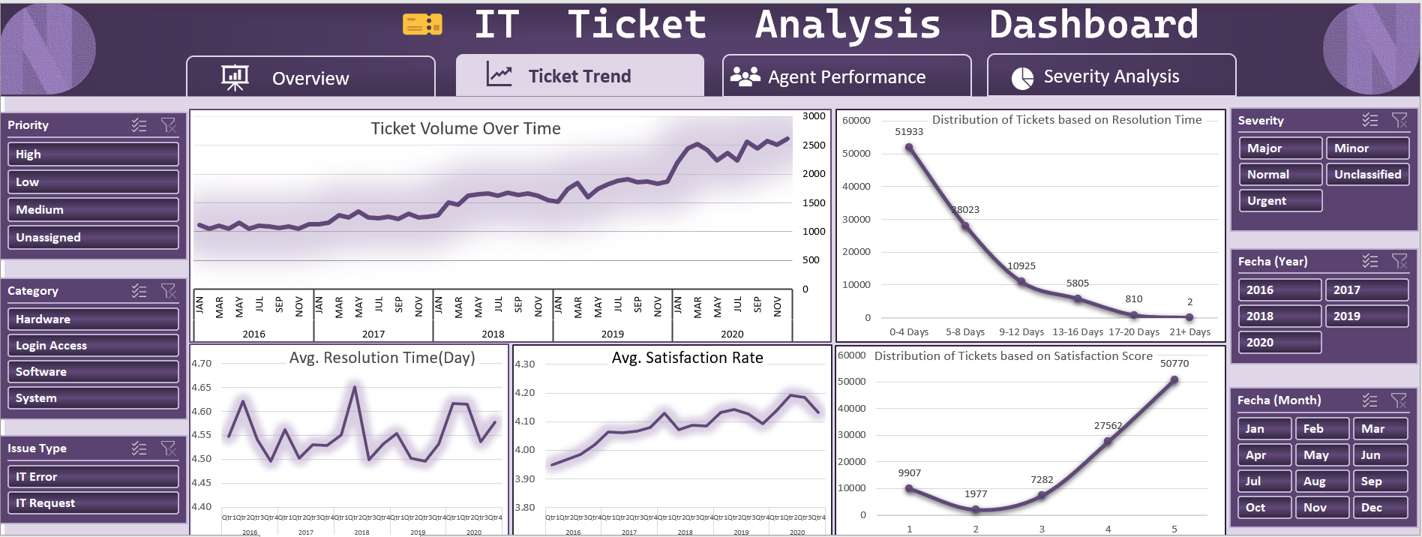
Q10) What metrics should be included in the final dashboard to provide a comprehensive view of call center performance and guide investment decisions?
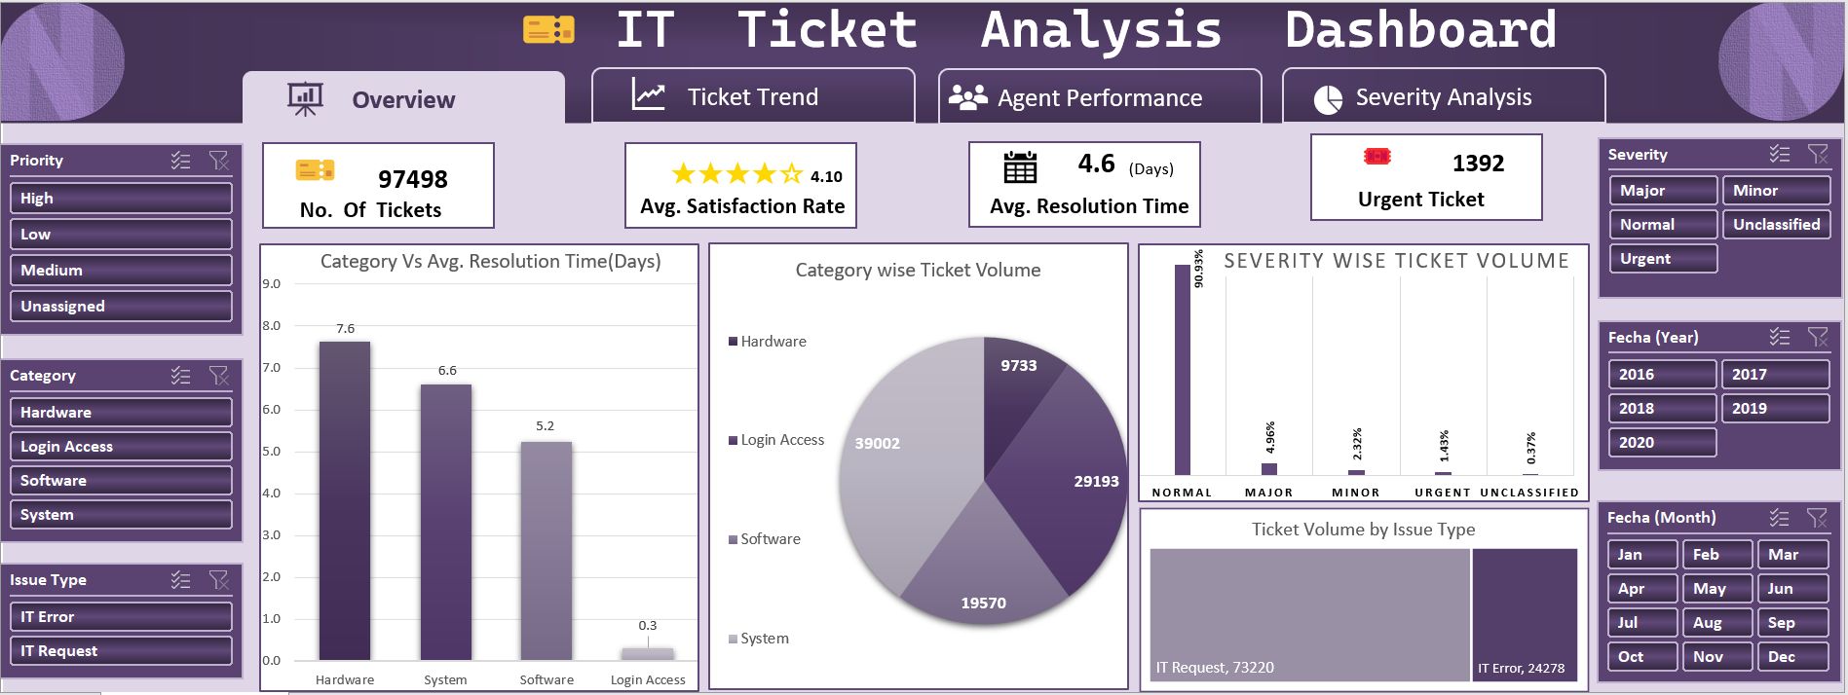
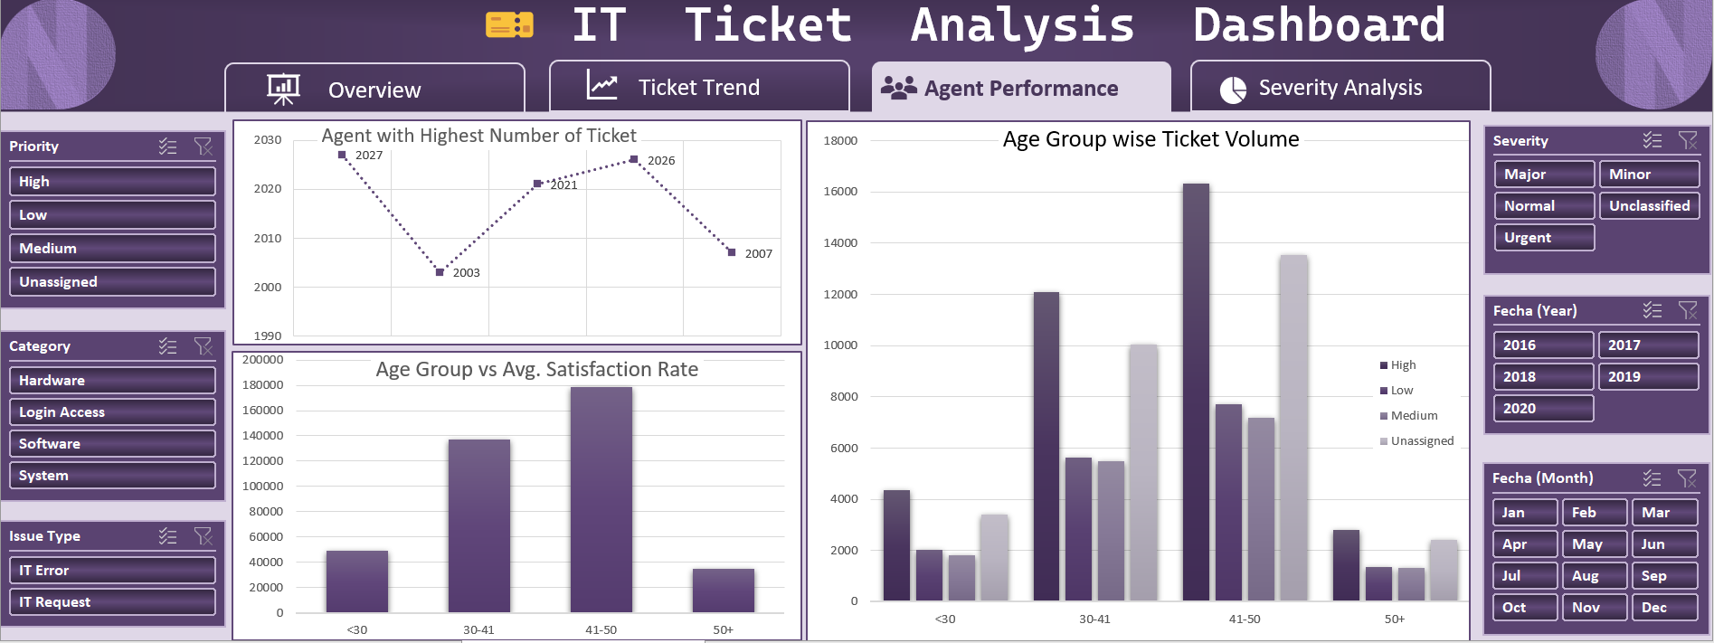
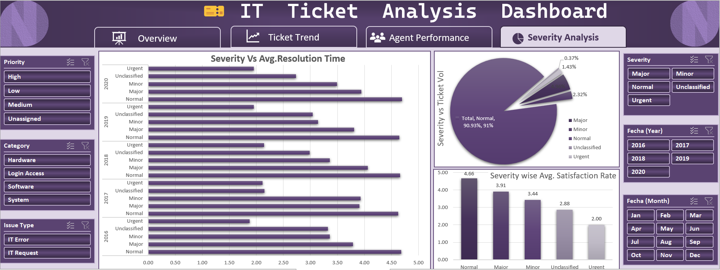
Strategic Objective of the Dashboard:
The goal of the final dashboard is to offer a 360-degree view of IT support operations, covering:
- Performance of agents
- Ticket workload & trends
- Quality of service (Satisfaction)
- Operational bottlenecks (Resolution Time)
- Priority/severity-driven filters for decision-makers
It should help management identify strengths, gaps, and where to invest — in tools, people, or process improvements.

Metrics Included in the Final Dashboard:
1. Total Number of Tickets Shown in: KPI Card {97498}
Purpose: Shows total volume of requests handled.
Why it matters: High volume may justify investment in automation or staffing.

2. Average Satisfaction Rate Shown in: KPI Card {4.1} & Trend Charts
Purpose: Measures user happiness with IT support.
Why it matters: Indicates service quality. A drop here means poor user experience and signals the need for tech upgrades, better training, or more staff.

3. Average Resolution Time Shown in: KPI Card + Multiple bar charts
Purpose: Measures efficiency of the support team.
Why it matters: Long times mean slower service, which may need better ticket routing, more agents, or AI solutions.

4. Ticket Volume Over Time Shown in: Line Chart (2016–2020)
Purpose: Trend in number of tickets over time.
Why it matters: Helps detect seasonal/annual workload patterns. Useful for proactive resource planning and budget allocation.

5. Resolution Time & Satisfaction Rate Over Time Shown in: Clustered bar chart (Quarterly view)
Purpose: Shows how speed and quality changed together over time.
Why it matters: Helps identify if faster resolutions reduced satisfaction, or vice versa — critical for balancing efficiency vs service quality.

6. Agent Performance – Top & Poor Performers Shown in: Left panel
Purpose: Highlights best and worst-performing agents.
Why it matters: Informs HR/training needs and reward decisions. Helps plan investment in workforce development.

7. Request Category-wise Resolution Time Shown in: Vertical bar chart
Purpose: Tracks how long each type of request takes (Hardware, Software, System, Login).
Why it matters: High resolution time in categories like Hardware (7.6 days) suggests urgent need for investment in hardware maintenance or infrastructure.

8. Ticket Distribution by Request Category Shown in: Pie Chart
Purpose: Shows volume of each request type.
Why it matters: Tells where most IT time is spent. High volume + high resolution = investment priority.

9. Issue Type (IT Request vs IT Error) Shown in: Stacked bar + card
Purpose: Breakdown of support nature.
Why it matters: Repeated IT errors may suggest software/system instability — triggers investment in IT systems/stability.

10. Severity Analysis Shown in: Pie chart (Distribution) + Bar chart (Resolution Time)
Purpose: Understand ticket priority and how fast they’re resolved.
Why it matters: Major/Urgent issues should ideally be resolved faster. Delays here can indicate weak SLA compliance, requiring staffing or automation investment.

Slicers for Decision-Making:
To ensure interactivity and support long discussions, the dashboard includes:
- Year-wise slicer (2016–2020): For annual performance reviews
- Priority slicer: To assess how High, Medium, or Low priority tickets are handled
- Category / Issue Type / Severity filters: For deep drill-down and targeted decisions
These filters allow management to explore scenarios, compare performance across conditions, and focus investment where it is most needed.

Conclusion:
The final dashboard includes all critical KPIs—volume, efficiency, satisfaction, agent productivity, and issue breakdown—backed with slicers that offer flexibility and focus.
It enables management to:
- Identify operational strengths and bottlenecks
- Pinpoint training needs or staffing issues
- Discover technology gaps (e.g., hardware/system inefficiencies)
- Prioritize investments backed by real-time data
This makes the dashboard not just informative, but a powerful decision-making tool for both operational management and strategic planning.

THANKYOU

